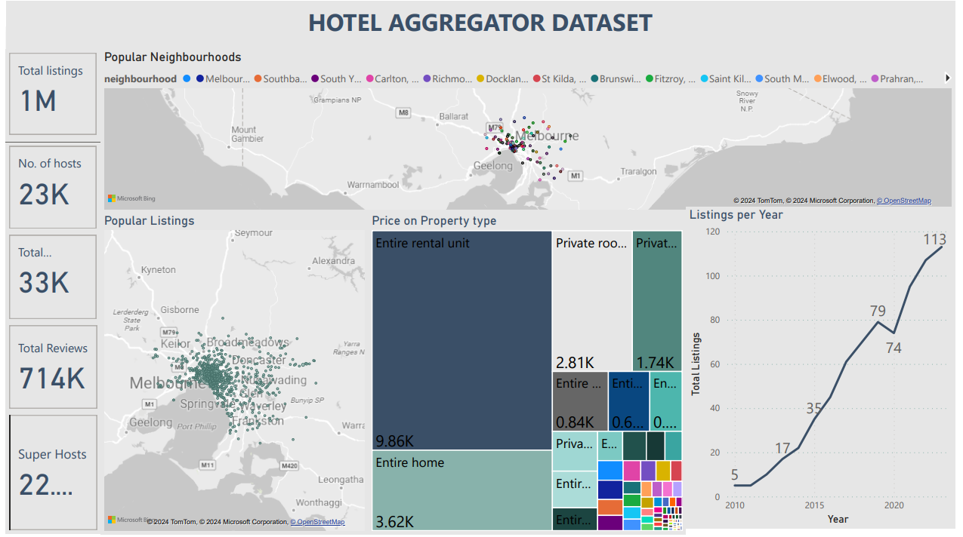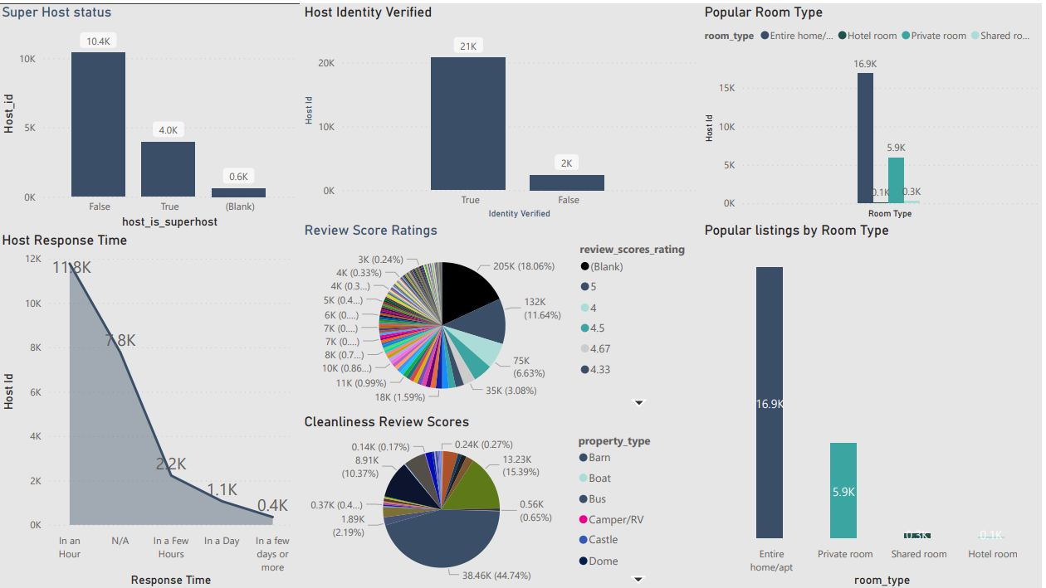

**HOTEL AGGREGATOR DATASET ANALYSIS WITH POWER BI**

INTRODUCTION: This analysis delves into the various attributes related to listings, hosts, reviews, and availability. The objective is to create comprehensive visualizations and insights that shed light on trends, patterns, and factors influencing the performance of listings. The goal of the Hotel Aggregator Analysis is to provide actionable insights that will explore key metrics such as pricing, availability, host characteristics, and review scores to derive actionable insights for improving the overall quality and competitiveness of the listings.

**IMPLEMENTATION OUTLINE**

**Analytics process**: The tool I will use for this case study is MS Excel and Power BI. The data analytics process will follow the PMAVD (Prepare, Model, Analyze, Visualize and Dashboard) process.

**a. Preparation:** I deployed the **OMG-C** method in the data preparation step. Objectives, Measures, Get and Clean the data.

**Objective:**

1. Calculate the necessary KPI.
2. Using an interactive visual, explore the top five reasons and insights that shed light on trends, patterns, and factors influencing the performance of listings.

b. Measures: The dataset for this task has fifty-two columns which contains id,description,neighborhood_overview ,host_id host_name,No. of hosts,host_is_superhost ,host_since, host_location,list of Countries,host_response_time, host_response_rate, host_acceptance_rate, host_neighbourhood, host_listings_count, host_total_listings_count,host_communication_method host_identity_verified,neighbourhood neighbourhood,cleansed,latitude,longitude,property_type room_type,accommodates,bathrooms_text ,bedrooms,beds amenities,Price, minimum_nights,maximum_nights minimum_avg_nights,maximum_avg_nights,has_availability ,availability_365,number_of_reviews first_review,last_review,review_scores_rating review_scores_accuracy,review_scores_cleanliness review_scores_checkin,review_scores_communication review_scores,location,review_scores_value insant_bookable,calculated_host_listings_count, calculated_host_listings,count_entire_homes calculated_host_listings,count_private_rooms, reviews_per_month.

1. DATA PREPARATION

I deployed the OMG-C method in the data preparation step. Objectives, Measures, Get and Clean the data.

Objective:

* Calculate the necessary KPI
* Using an interactive visual, explore the top five reasons and insights that shed light on trends, patterns, and factors influencing the performance of listings Get and Clean Data

In Hotel Aggregator sheet I removed some columns that is not needed from the objectives.

**2. Exploratory Data Analysis (EDA)**

EDA are a set of steps used to explore and understand the data better before cleaning and transformation.

**a. Cleaning and Transformation**

- Convert dataset into table: Ctrl A, Ctrl T, “OK”

- Export to power query: Go to “Data”, **Select** “From table”.

- Check for number of rows: Go to “Transform”, **Select** “Count Rows”

Columns: 52 Rows: 23,184.

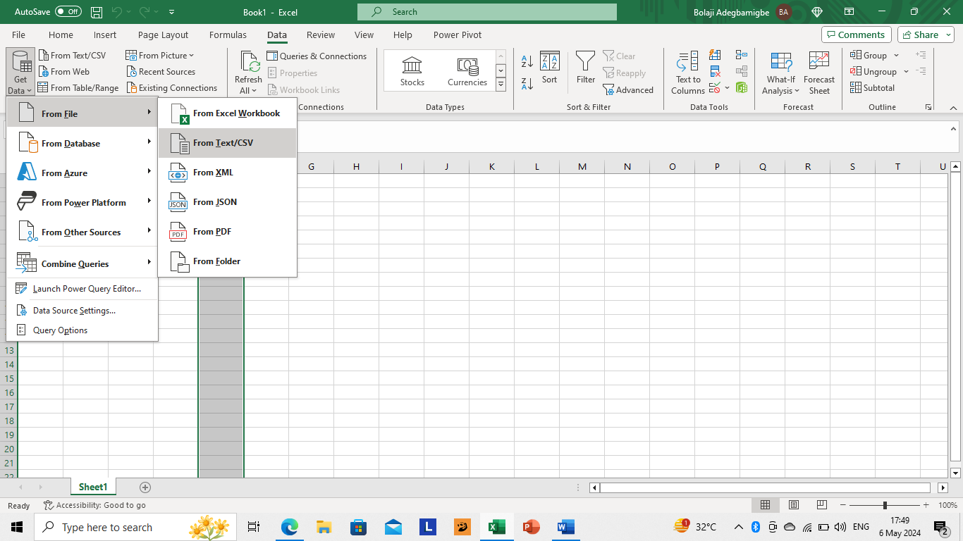

this picture above is a blank worked that enabled me o get the dataset from my file location

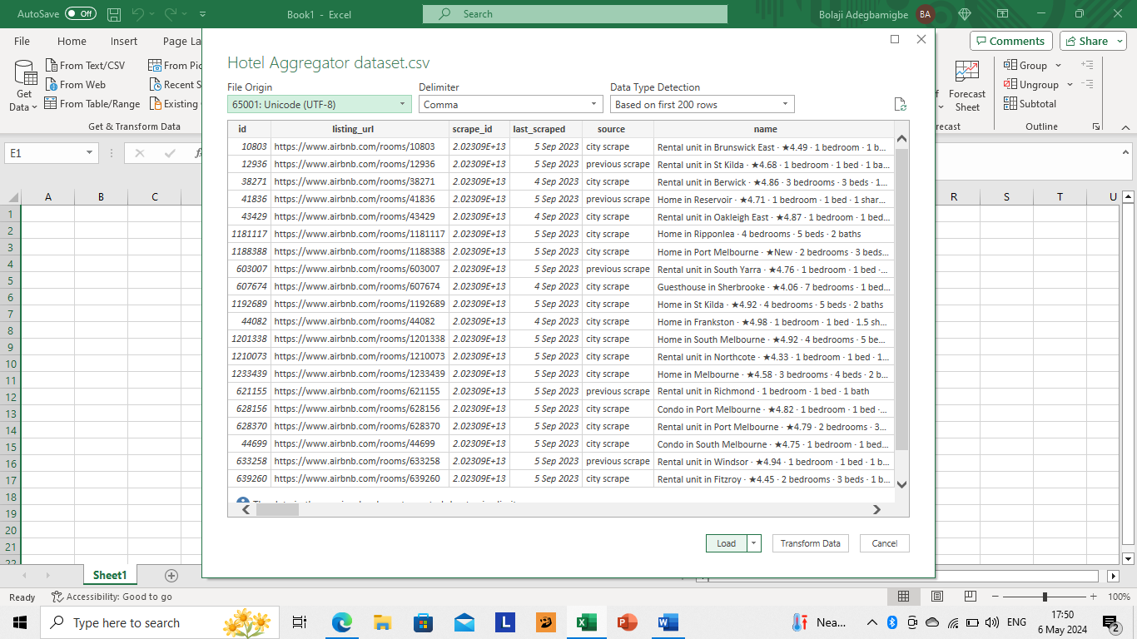

The picture above is when I located the dataset from my file location (ETL PROCESS)

BELOW IS THE DATASET BEFORE CLEANING 1

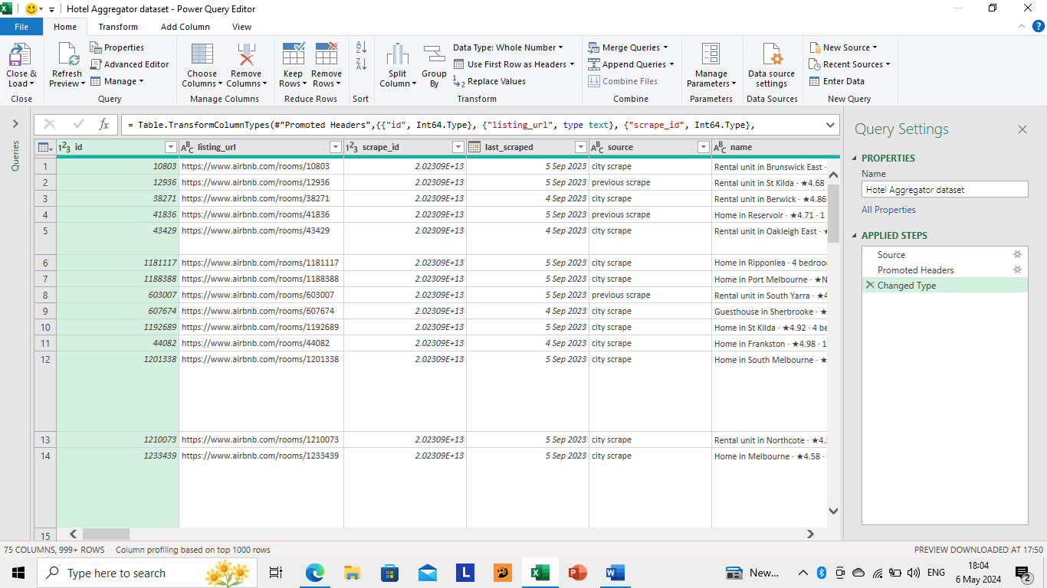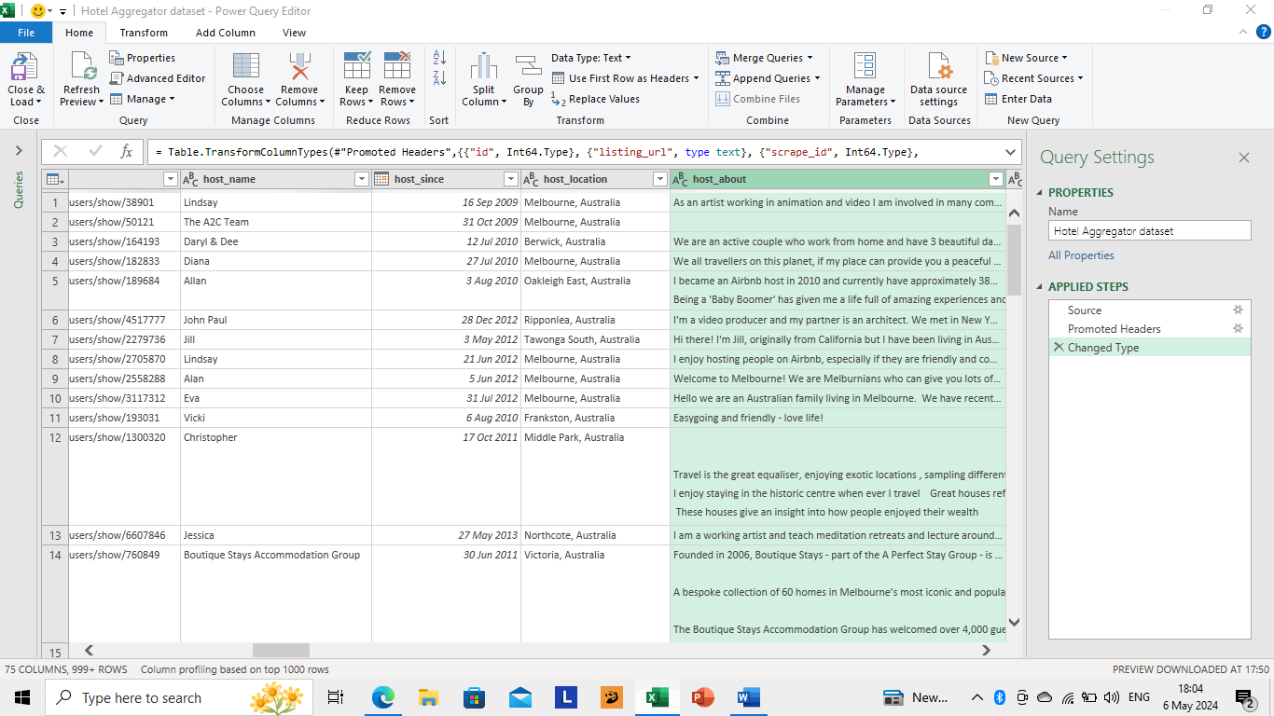

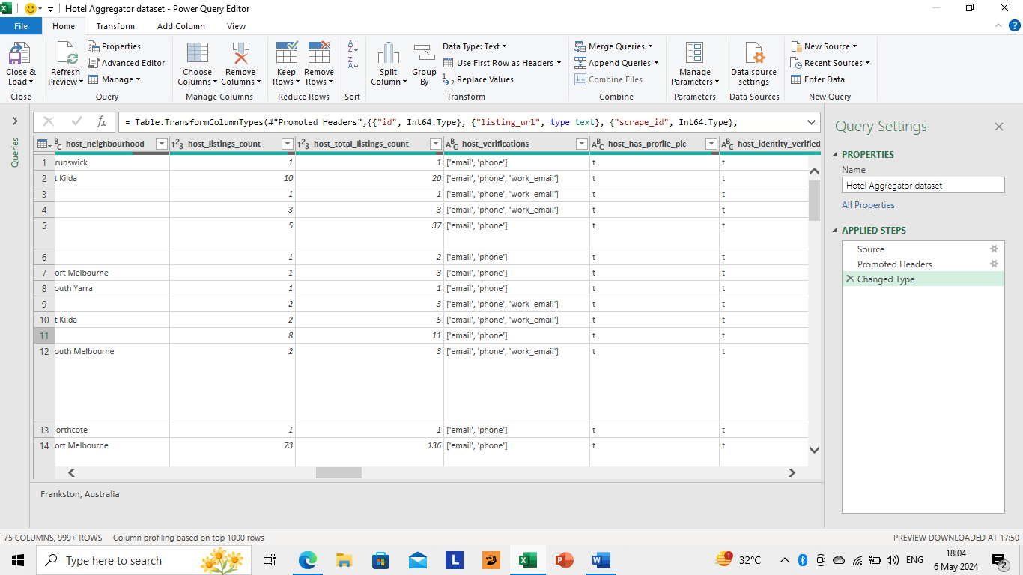

REMOVING COLUMNS THAT I DONT WANT TO USE FOR THE ANALYSIS



* The Column host_is_superhost contains letters (t and f) only, From the dataset source, they represent the following

T = True

F = False

* The Column host_identity_verified contains letters (t and f) only, From the dataset source, they represent the following.

T = True

F = False

* The Column has_availabilty contains letters (t and f) only, From the dataset source, they represent the following.

T = True

F = False

I replaced the numbers with their true values. Then, changed the datatype of other columns.

And replaced all numerical values with the appropriate educational values.

AFTER CLEANING

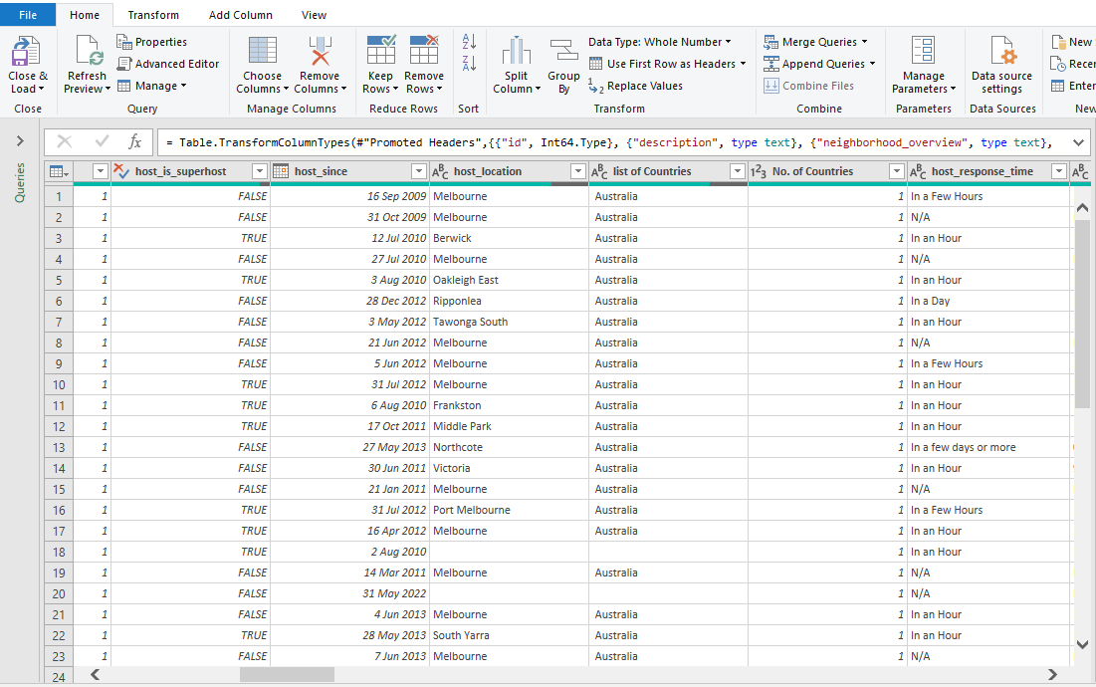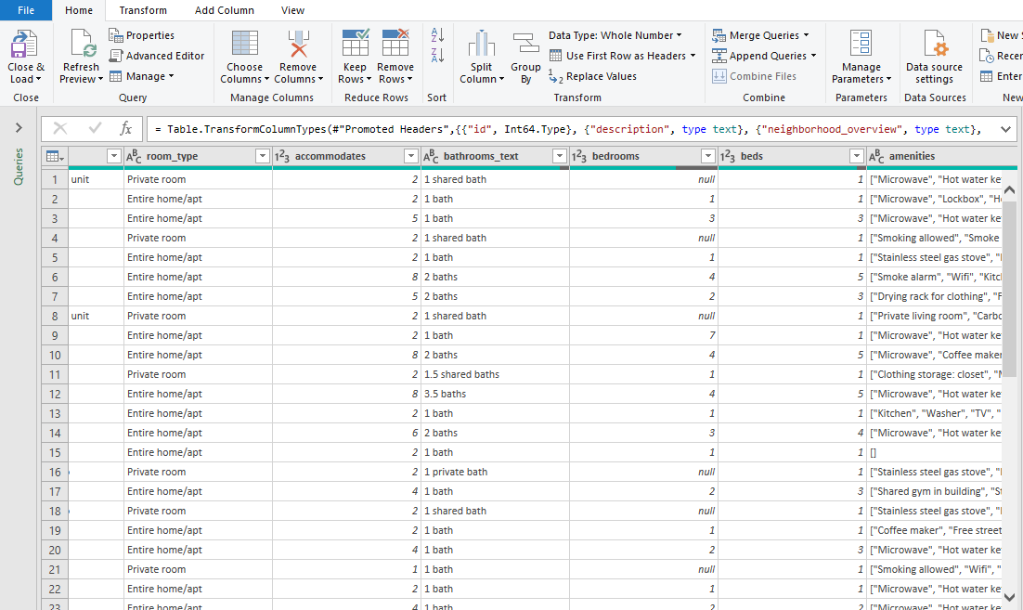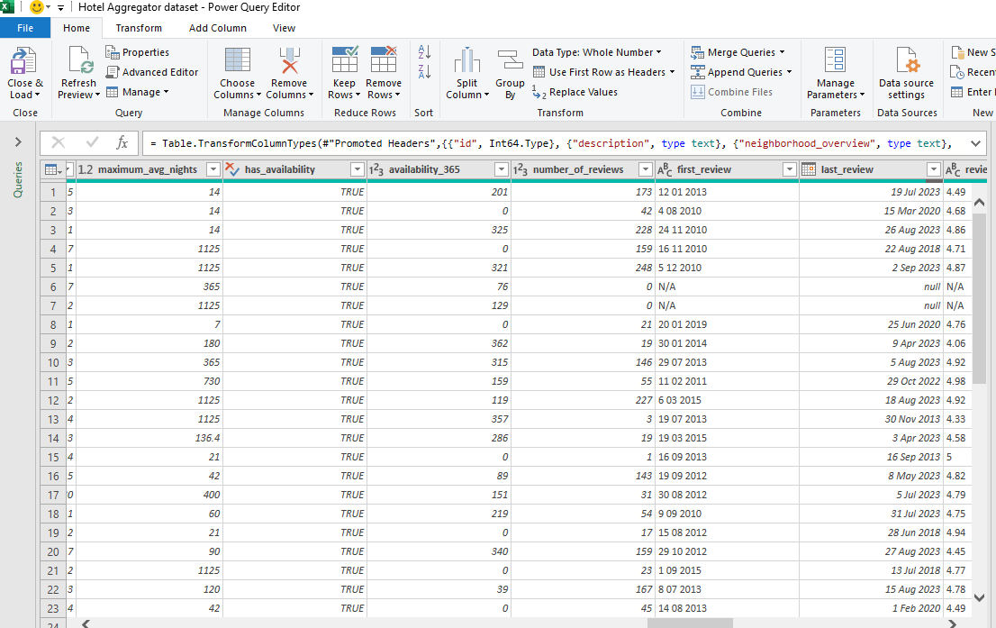

After the whole cleaning process, I closed and load the data back to Excel for me to carry out an analysis known as data modeling with the help of a tool called Power BI.

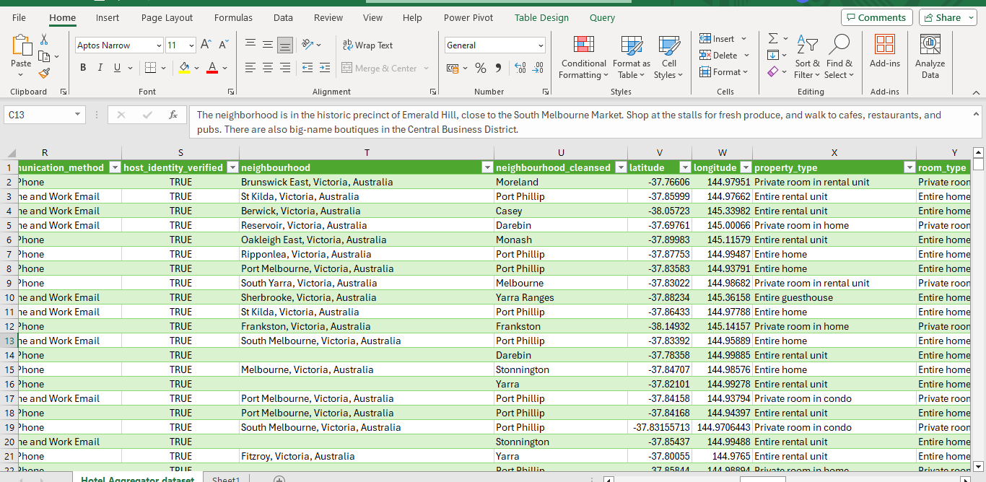

**DATA MODELING USING POWER BI**

I generated all the necessary KPI like

Total Listings

No. of Hosts

Total Bedrooms

Total Reviews

Super Hosts

All the insights that shed light on trends, patterns, and factors influencing the performance of listings where gotten from this Power BI analysis as shown below with the help of charts and graphs.

VISUALS AND DASHBOARD



**INSIGHTS**: After the whole analysis, visualization creation ,and reports to track the total listings key performance indicator

Total Listings = 1,000,000

No. of Hosts = 23,000

Total Bedrooms = 33,000

Total Reviews = 714,000

Super Hosts = 22,500

Analyzing historical data

Distribution of Listings by Popular Neighborhoods : Melbourne, Australia has a total listing of 229,000

The most popular geographical concentration of listings and host locations is Australia.

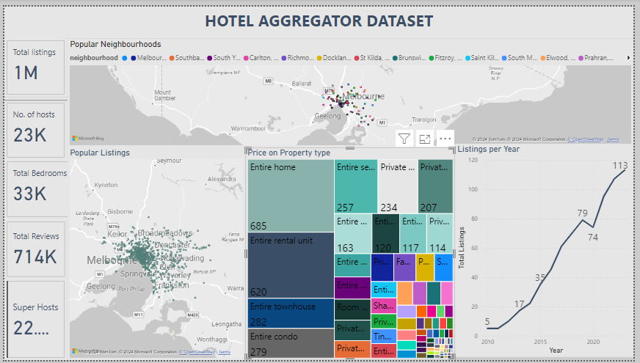

The most expensive property type is “Entire Home”

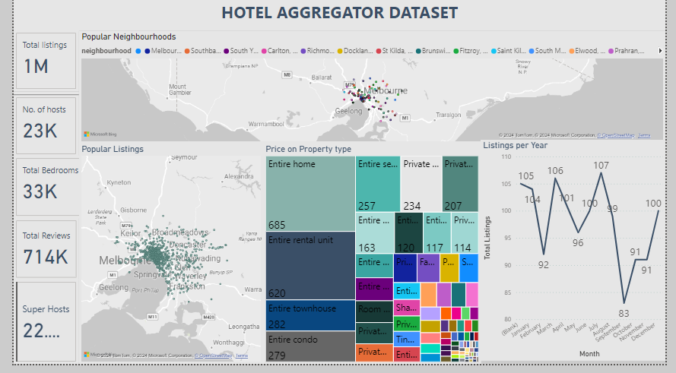

The month of July is the peak period for the availability of listings.



Hosts with “Super host status” are less than hosts without the “Super host status”.

Hosts that respond within an Hour(118k) is more than any other response time, the least is “In a few days or more”.

Hosts that have their identity verified(21k) are more than hosts that don’t have their identity verified.

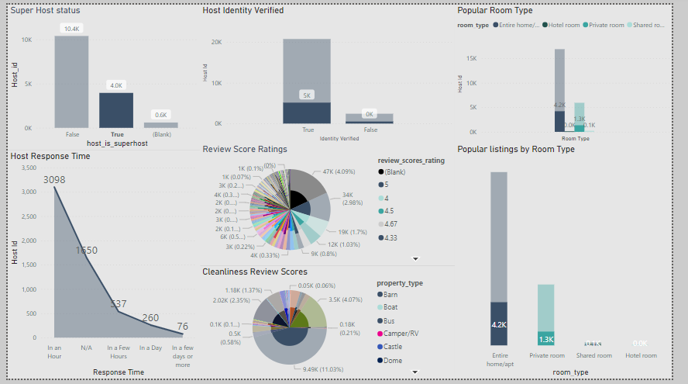

Super hosts generate more listings compared to hosts without the “Super host” status.

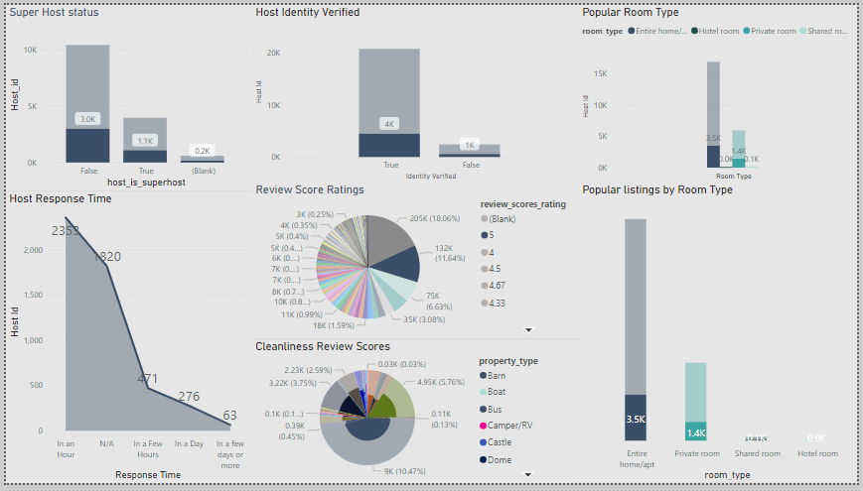

Hosts with 5 stars generate more listings according to the pie chart

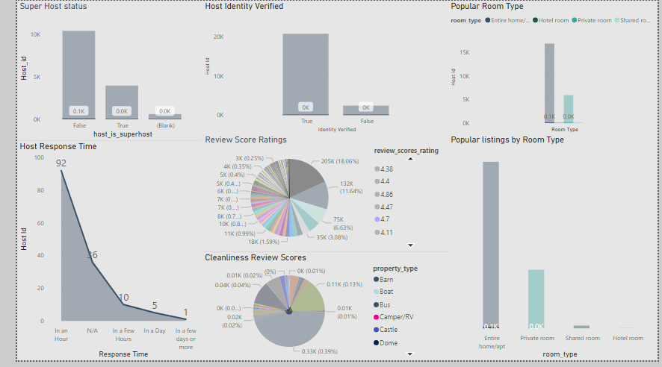

Hosts with less than 5 stars need improvement with cleanliness and response time.

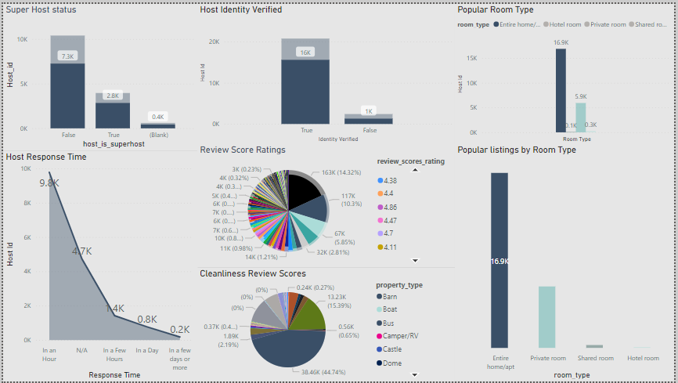

The popular room type according to the illustration is the “Entire home/apartment.”

**RECOMMENDATION**

**Listing Analysis**

The goal of the Hotel Aggregator Analysis is to provide actionable insights that will explore key metrics such as pricing, availability, host characteristics, and review scores to derive actionable insights for improving the overall quality and competitiveness of the listings. Monitor insights that shed light on trends, patterns, and factors influencing the performance of listings.

**Market Segmentation and Targeting:**

Understanding customers better by dividing them into groups based on things like age, interests, how they travel, and what they like when booking. Use smart techniques to group similar customers together, so that we can see what they want and need. Create special deals and messages for each group to make them feel special and keep them coming back.

**Competitive Analysis:**

Take a close look at what competitors are doing well and where they might be falling short. Compare how you're doing against industry standards and your main rivals to find areas where you're doing great and spots what can be done better. Use what is learnt to set prices, make offers stand out, and make sure you're in a strong position in the market.

**Customer Experience Enhancement**:

Make sure your customers have a great experience from start to finish. Invest in easy-to-use websites and apps, and make sure booking is smooth. Listen to what your guests say and use that to make your service better all the time.

**Ethical and Transparent Business Practices:**

Uphold ethical business practices, transparency, and integrity in all dealings with customers, partners, and stakeholders.

Communicate transparently about pricing, fees, terms, and conditions to build trust and credibility with customers and foster long-term relationships.

By implementing these elaborate recommendations, a hotel aggregator can enhance competitiveness, drive sustainable growth, and deliver exceptional value to customers in a dynamic and evolving market landscape.

Top of Form

Top of Form